Sewn Worry Monster
This is just a suggestion please be as creative as possible, the only necessity is that it has a pocket. This could be the mouth or a patch pocket or even a concealed pocket.

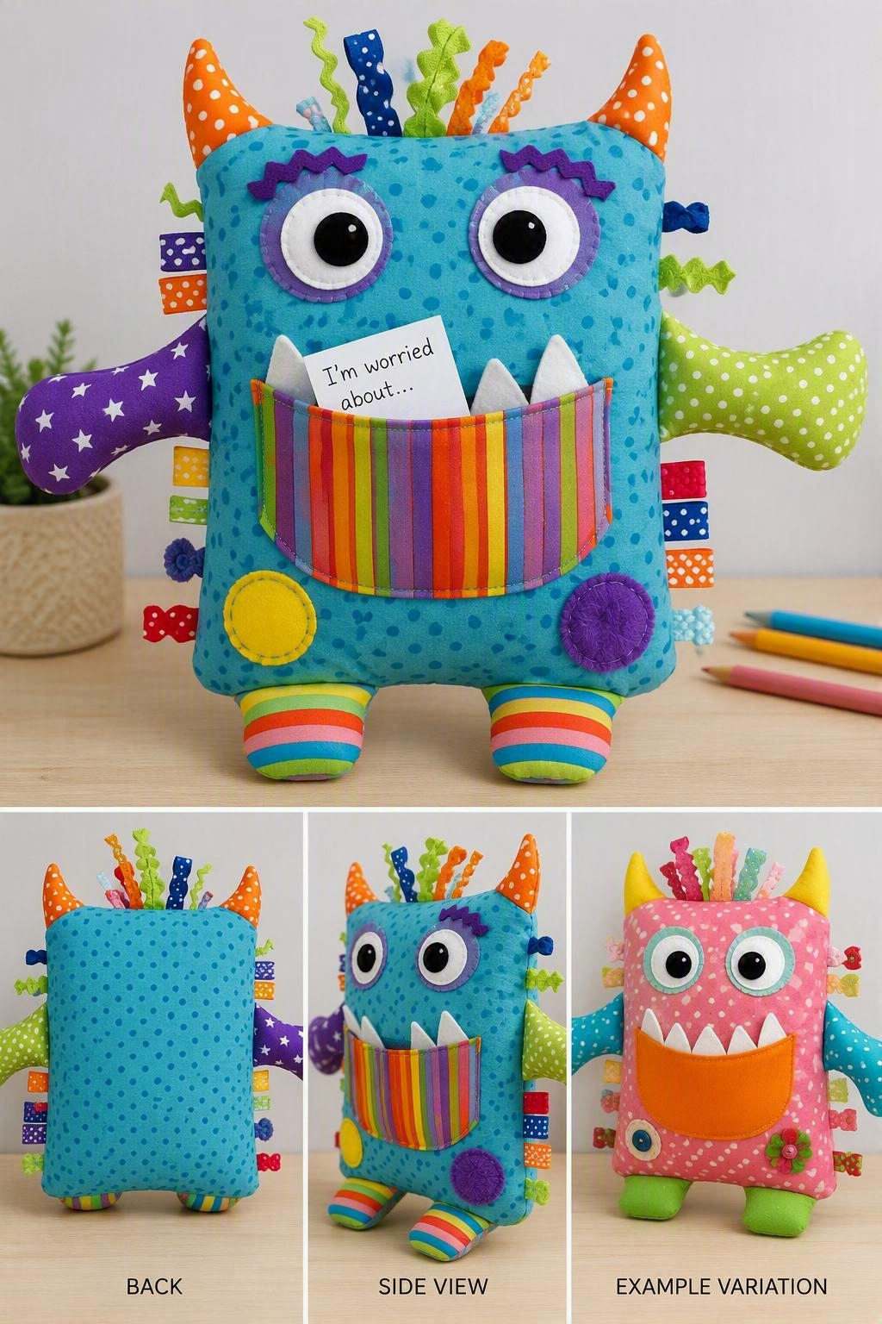
Finished Size
Approximately 8" wide × 10" tall
Materials
- Two pieces of cotton
- Scraps of felt for eyes, teeth, horns, etc.
- Matching thread
- Toy stuffing
- Safety eyes (optional)
- Ribbon scraps, ric-rac, buttons, fleece strips, or sensory trims
- Sewing machine or hand-sewing needle
Pattern Pieces
Body
Cut:
- 2 rectangles measuring 9" × 11"
Mouth Pocket
Cut:
- 1 rectangle measuring 8" × 5"
Optional Extras
Cut from felt:
- 2 eyes (1½" circles)
- Teeth (small triangles)
- Horns
- Spots
- Ears
- Arms and legs

Preparing the Mouth
Step 1
Take the mouth piece (8" × 5").
Fold the top long edge over ¼", then another ¼".
Stitch across to create a neat hem.
This becomes the opening of the monster's mouth.
Step 2
Position the mouth pocket on the right side of one body piece.
Place it approximately 3" down from the top edge.
Pin and sew around the sides and bottom only.
Leave the hemmed top edge open.
The pocket is where worries are stored.

Decorating the Monster
Before assembling, add the face.
Ideas include:
- Felt eyes
- Button eyes (for older children only)
- Embroidered eyes
- Felt teeth tucked under the mouth opening
- Ric-rac eyebrows
- Ribbon hair
- Felt spots and patches
Make every monster unique.

Assembly
Step 1
Place the two body pieces right sides together.
Step 2
Sew around all four sides using a ½" seam allowance.
Leave a 3" gap for turning.
Step 3
Clip corners.
Turn right side out.
Step 4
Stuff lightly.
A worry monster should be soft rather than firm.
Step 5
Hand-stitch the opening closed.

Optional Arms and Legs
Cut:
- Four arm pieces
- Four leg pieces
Sew pairs together.
Turn and stuff lightly.
Insert into side seams before sewing the body closed, or attach afterwards.

Sensory Version
For use as a twiddle or comfort toy, add:
- Ribbon loops
- Fleece tassels
- Braided yarn
- Crinkle material inside ears
- Large textured patches
- Corduroy, velvet, and faux fur fabrics
- Zips, buckles, and tabs (securely attached)

Quick Pattern Summary
- Body: Cut 2 rectangles, 9" × 11"
- Mouth Pocket: Cut 1 rectangle, 8" × 5"
- Finished Size: Approximately 8" × 10"
- Stuff lightly
- Add eyes, teeth, horns, ribbons, and other fun features
The beauty of a worry monster is that there are no rules. The sillier, brighter, and more colourful it is, the more appealing it becomes for children to interact with.

