Triangular Shawl
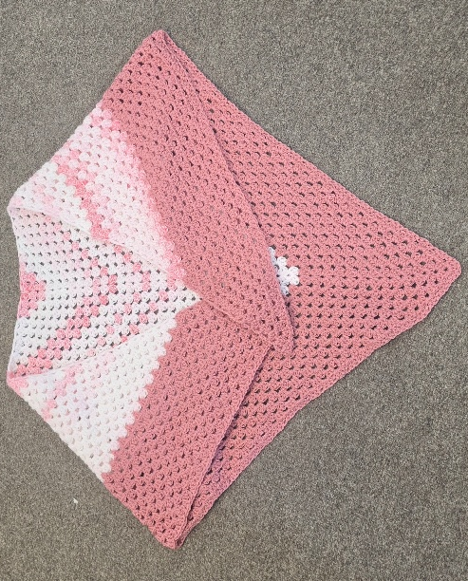
Finished Size
- Wingspan: approximately 180 cm (71 in)
- Depth at centre: approximately 75 cm (30 in)
Size is easily adjustable by working more or fewer repeats.
Materials
- 800-1,000 m (875-1,100 yd) fingering or 4-ply yarn
- 4.0 mm (US 6) circular knitting needle (80 cm or longer)
- 2 stitch markers
- Tapestry needle
Tension
Not critical for this project.
Abbreviations
- K = knit
- P = purl
- YO = yarn over
- K2tog = knit 2 stitches together
- PM = place marker
- SM = slip marker
Shawl Construction
The shawl is worked from the top centre downward. Four increase points create the triangle shape.

Setup
Cast on 5 stitches.
Row 1 (WS): Knit all stitches.
Row 2 (RS): K2, YO, PM, K1, PM, YO, K2 (7 sts)

Increase Section
Repeat the following two rows until shawl measures approximately 55-60 cm (22-24 in) from cast-on edge.
Right Side Row
K2, YO, knit to marker, YO, SM, K1, SM, YO, knit to last 2 sts, YO, K2
Wrong Side Row
Knit all stitches.
You are increasing 4 stitches every right-side row.

Lace Border
When the shawl reaches your desired body size, begin the border pattern.
Row 1 (RS)
K2, YO, K2tog, YO repeat to marker, YO, K1, YO, repeat from * to last 2 sts, K2
Row 2 (WS)
Knit all stitches.
Row 3 (RS)
K2, YO, K2tog repeat to marker, YO, K1, YO, repeat from * to last 2 sts, K2
Row 4 (WS)
Knit all stitches.
Repeat Rows 1-4 six to ten times, depending on the depth of lace desired.

Picot Bind Off
For a decorative edge:
- Cast on 2 stitches using knitted cast-on.
- Bind off 4 stitches.
- Return the remaining stitch to the left needle.
- Repeat around the entire shawl edge.
Alternatively, use a stretchy bind-off if preferred.

Finishing
- Weave in all ends.
- Soak the shawl in lukewarm water.
- Gently squeeze out excess water.
- Pin out to full triangular shape, opening the lace border.
- Allow to dry completely.

