Crochet Twiddlemuff Pattern
Materials
- Approx. 150 g DK, aran, or chunky yarn
- Appropriate hook size for your yarn
- Tapestry needle
- Assorted tactile embellishments:
  - Buttons (securely sewn)
  - Ribbons
  - Braided yarn cords
  - Wooden rings
  - Beads enclosed in crochet tubes
  - Textured crochet motifs
Finished Size
- Approximately 30 cm (12 inches) wide
- Approximately 60 cm (24 inches) long before folding
Pattern
Foundation
Chain enough stitches to measure about 30 cm (12 inches) across.
Examples:
- DK yarn with 4 mm hook: approximately 50-60 chains
- Aran yarn with 5 mm hook: approximately 40-50 chains
- Chunky yarn with 6 mm hook: approximately 30-40 chains
Row 1
Starting in the second chain from hook, work 1 double crochet (UK terminology) / single crochet (US terminology) in each chain across.
Turn.
Rows 2-?
Repeat Row 1 until the piece measures approximately 60 cm (24 inches) long.
Alternatively, for a softer fabric you can use:
- UK half treble crochet (US half double crochet), or
- Alternate rows of front-loop and back-loop stitches for texture.
Fasten off and weave in ends.
Assembly
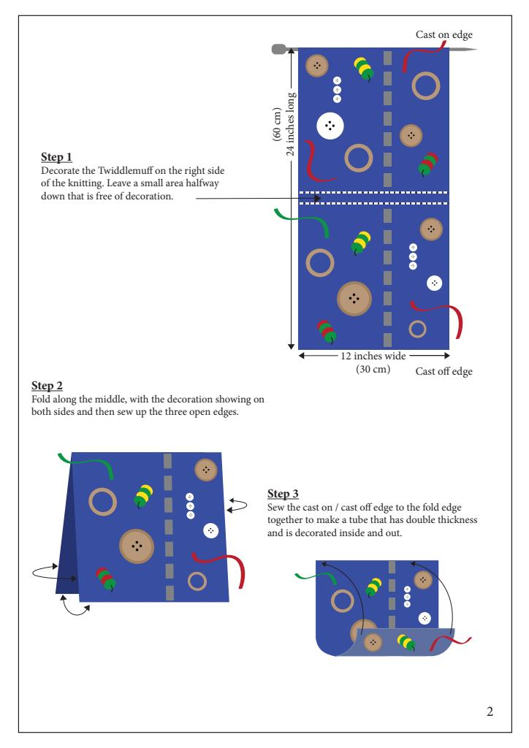
Leave a small undecorated strip across the centre of the rectangle.
- Add tactile decorations to the right side of the crochet fabric.
- Fold the rectangle in half widthwise so the decorations are visible on both the inside and outside.
- Sew the three open edges together.
- Join the cast-on edge and cast-off edge to create a circular double-thickness muff.
Crochet Twiddles (instead of sewn embellishments)
For extra sensory interest, crochet and attach:
- Corkscrew spirals: chain 25, work 3 dc into each chain.
- Bobbles: create bobble stitches scattered across the fabric.
- Chains threaded through eyelets.
- Small crochet flowers.
- Textured strips made with front-post stitches.
- Tube-shaped cords containing large wooden beads.
Dementia-Friendly Safety Notes
- Avoid loose beads or small parts that could detach.
- Sew all embellishments extremely securely.
- Avoid sharp edges, metal findings, or long loops that could catch fingers.
The finished item should look like the folded double-layer sensory muff illustrated here: and
If you'd like, I can also create a fully textured crochet twiddlemuff pattern with bobbles, ribbing, popcorn stitches, and sensory elements built directly into the crochet fabric.

