SizeMICRO:1.5to2.5lbs
SizeTINY:2to4lbs
SizePREEMIE:3to6lbs
SizeNEWBORN:5to8lbs
SizeINFANT:9to12lbs
AngelGown
(
ClassicKimono
)
Front:Cut1onFold,Cut1LiningonFold
Center-Front:cutfabriconfold
StraightGrain
charitableuseonly;
pleasedonotcopyorsell
”TestSquare
2
SizePREEMIE:3to6lbs
SizeNEWBORN:5to8lbs
SizeINFANT:9to12lbs
SizeTINY:2to4lbs
SizeMICRO:1.5to2.5lbs
AngelGown
ClassicKimono
(
)
Front:Cut1onFold,Cut1LiningonFold
charitableuseonly;
pleasedonotcopyorsell
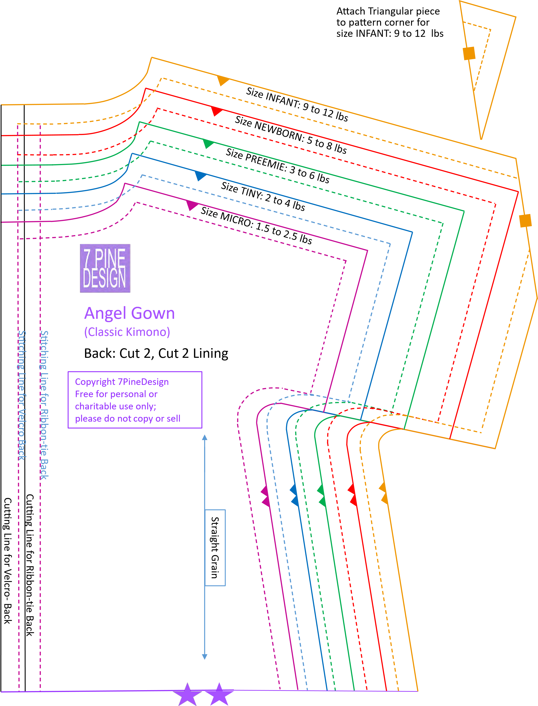
AngelGown
)
ClassicKimono
(
Back:Cut2,Cut2Lining
charitableuseonly;
pleasedonotcopyorsell
SizeTINY:2to4lbs
SizeMICRO:1.5to2.5lbs
SizePREEMIE:3to6lbs
SizeNEWBORN:5to8lbs
SizeINFANT:9to12lbs

